Hey guys,
I found several articles on rear sway bar for ILX/ Civic but not much for front. So I thought I would share my experience doing such an upgrade. Upgrading the antiroll bars are not something for drivers who speed, it really makes the car more steady when hitting a break or cornering. In other words it will handle better in unexpected situations.
The tools needed are sockets 10mm, 14mm, 17mm and 19mm. 14mm Wrench, different extensions, 5mm allen and Flat screw driver.
(I take no responsibility for your actions, I believe this is a community where we share our experiences while working on cars)

- Start by jacking up your car and remove the lower panel. There are 2 10mm bolts at the front of the car and around 6 plastic clips holding the panel.
- Start loosening the 17mm bolts to lower the sub frame, make to remove the rear bolts but keep the front ones attached. Pic
- Remove the 2 19mm steering bolts, one on the left and one on the right, however to access it is from above and not below. You barely can see the bolts but you need to remove them both. When installing back make sure the car steering wheel is centered otherwise you will have tilt steering wheel. Pic
- With the 14mm wrench and 5mm Allen remove the joint linked to the end of the sway bar.
- Now on the sway bar itself there are 4 bolts 14mm need to be removed with the metal bracket.
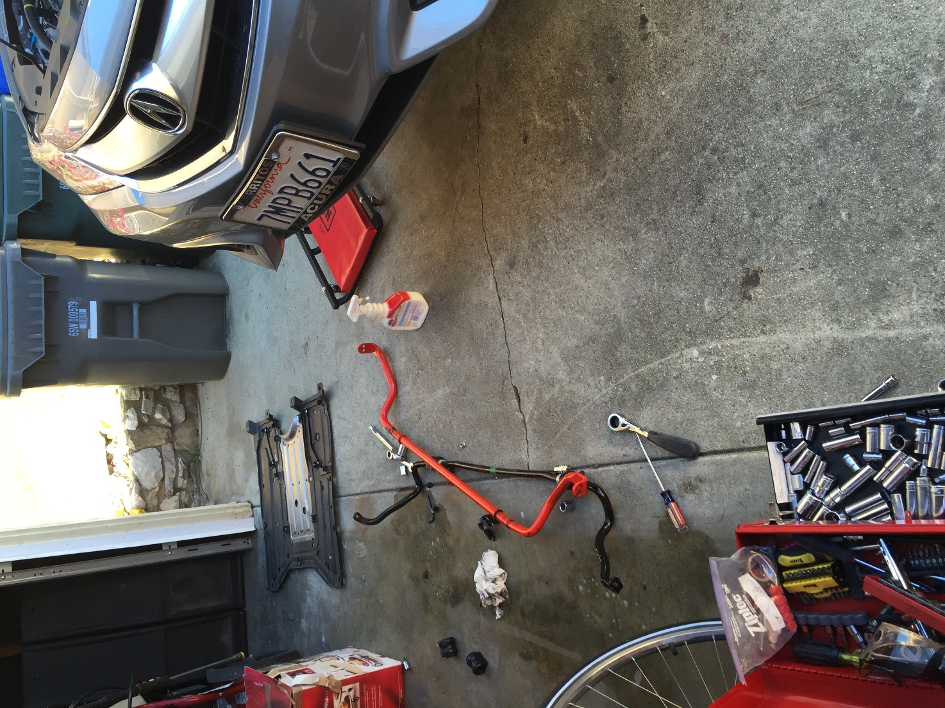

Remove the underbody plastic cover panel 2 10mm bolts and 6 plastic clips
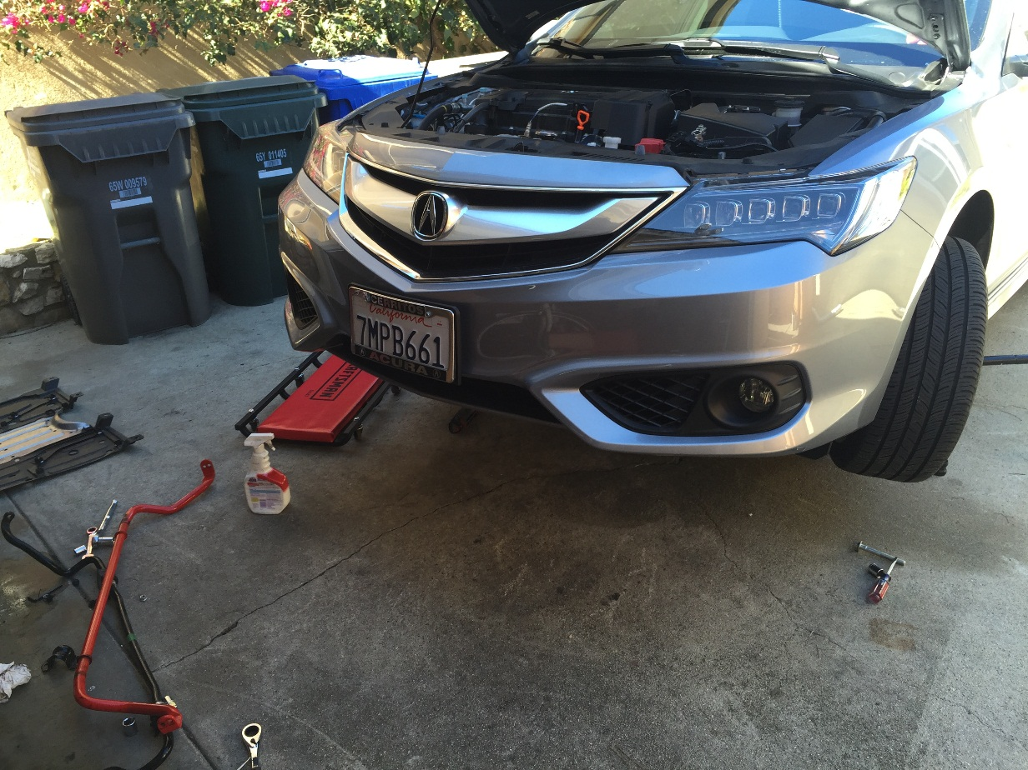
Difference between the original sway bar 20mm and Eibach 24mm
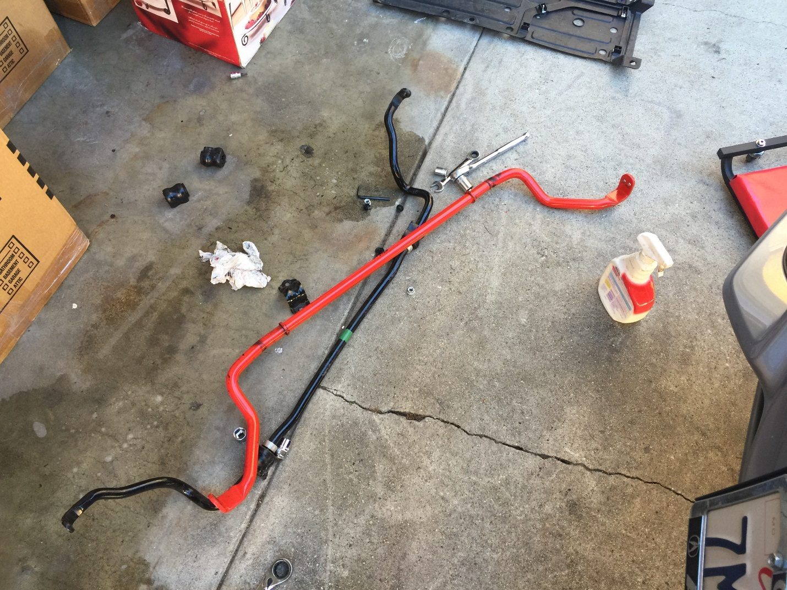
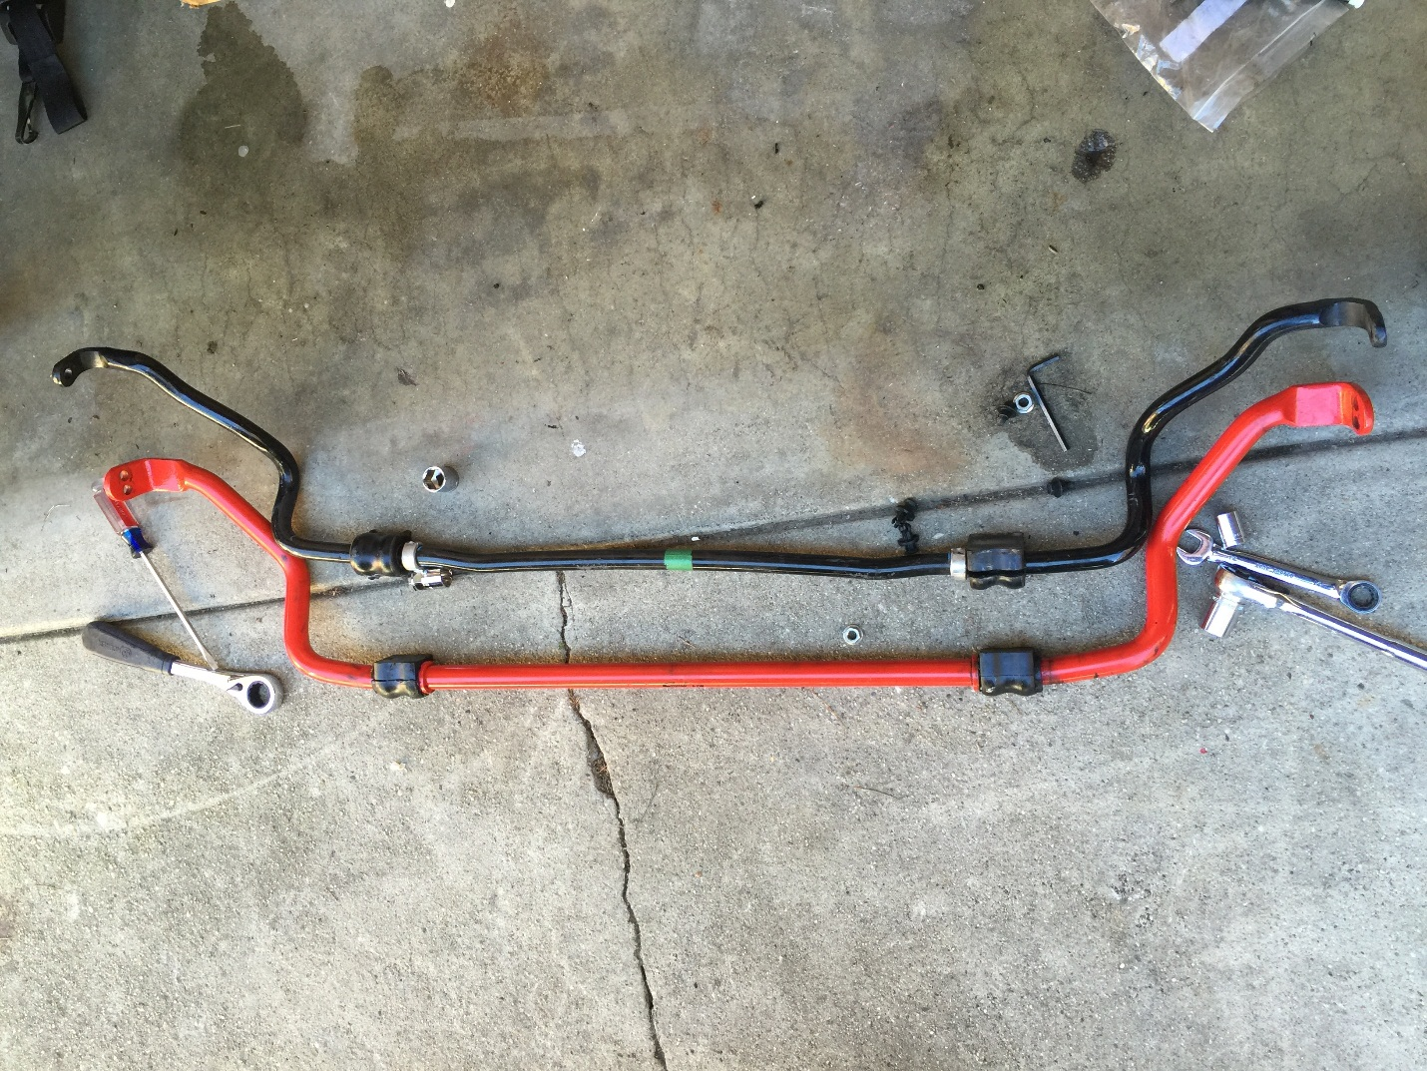

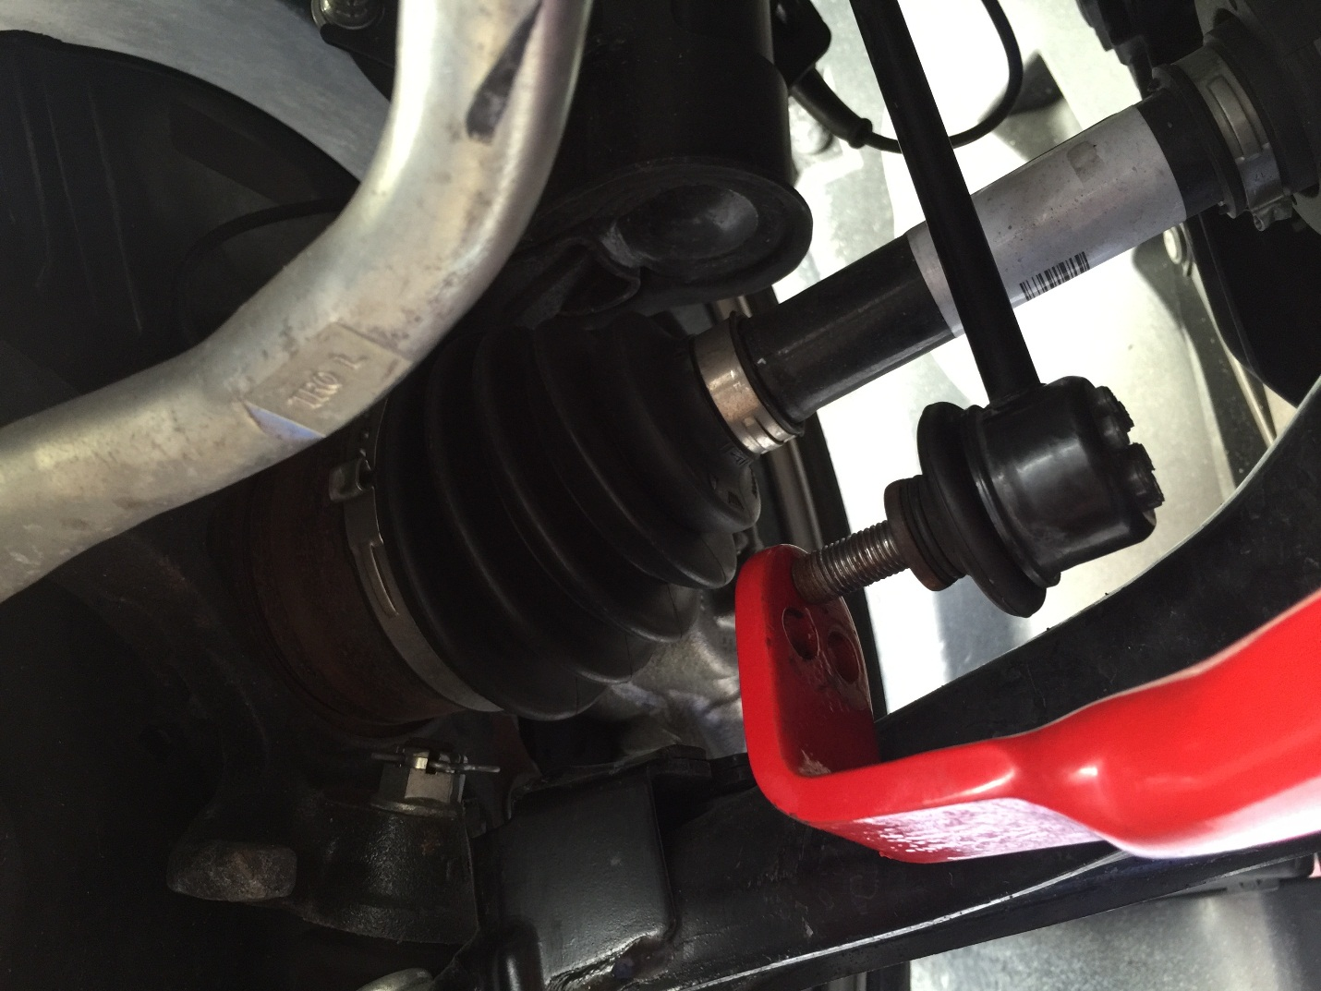
The Eibach has soft and hard setting
