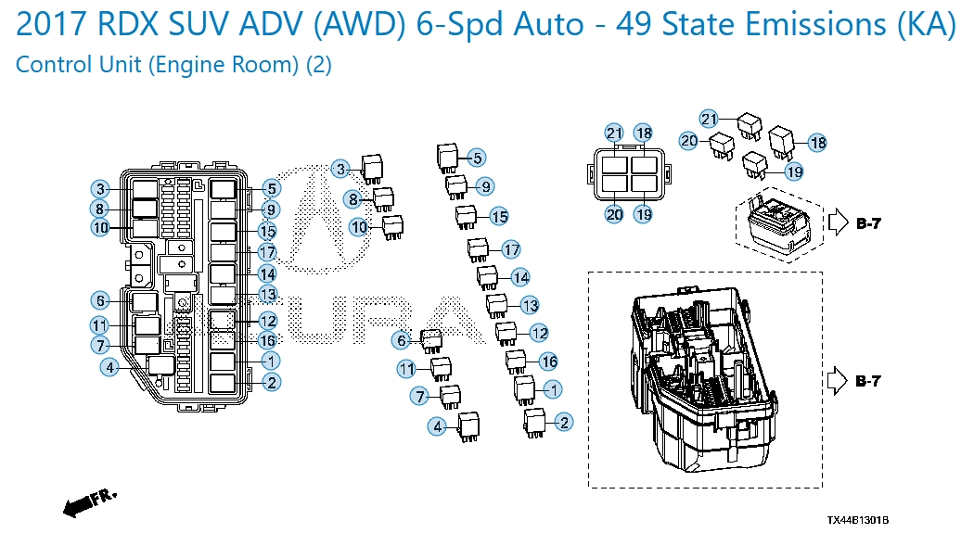
Relay No | Purpose | Part Number
1 | WIPER INTERVAL | 39792-SJC-A01
2 | WIPER HI/LO | 39792-SJC-A01
3 | BLOWER | 39792-SJC-A01
4 | RR DEFOGGER | 39792-SJC-A01
5 | FAN HI/LOW | 39794-S10-003
6 | IGNITION COIL | 39794-SDA-902
7 | SUB FUEL INJECTION | 39794-SDA-A03
8 | ACM | 39794-SDA-A03
9 | RADIATOR FAN MAIN FAN | 39794-SDA-A03
10 | SUB-FAN | 39794-SDA-A03
11 | WIPER MAIN | 39794-SDA-A03
12 | HORN | 39794-SDA-A03
13 | FR. FOG STARTER CUT 1 | 39794-SDA-A03
14 | R. HEADLIGHT LOW | 39794-SDA-A03
15 | L. HEADLIGHT LOW | 39794-SDA-A03
16 | SMALL LIGHT | 39794-SDA-A03
17 | MAGNETIC CLUTCH | 39794-SDA-A05
18 | STOP LIGHT | 39794-S10-003
19 | E-DPS | 39794-SDA-A02
20 | DAYTIME LIGHT | 39794-SDA-A03
21 | FR. FOG | 39794-SDA-A03

